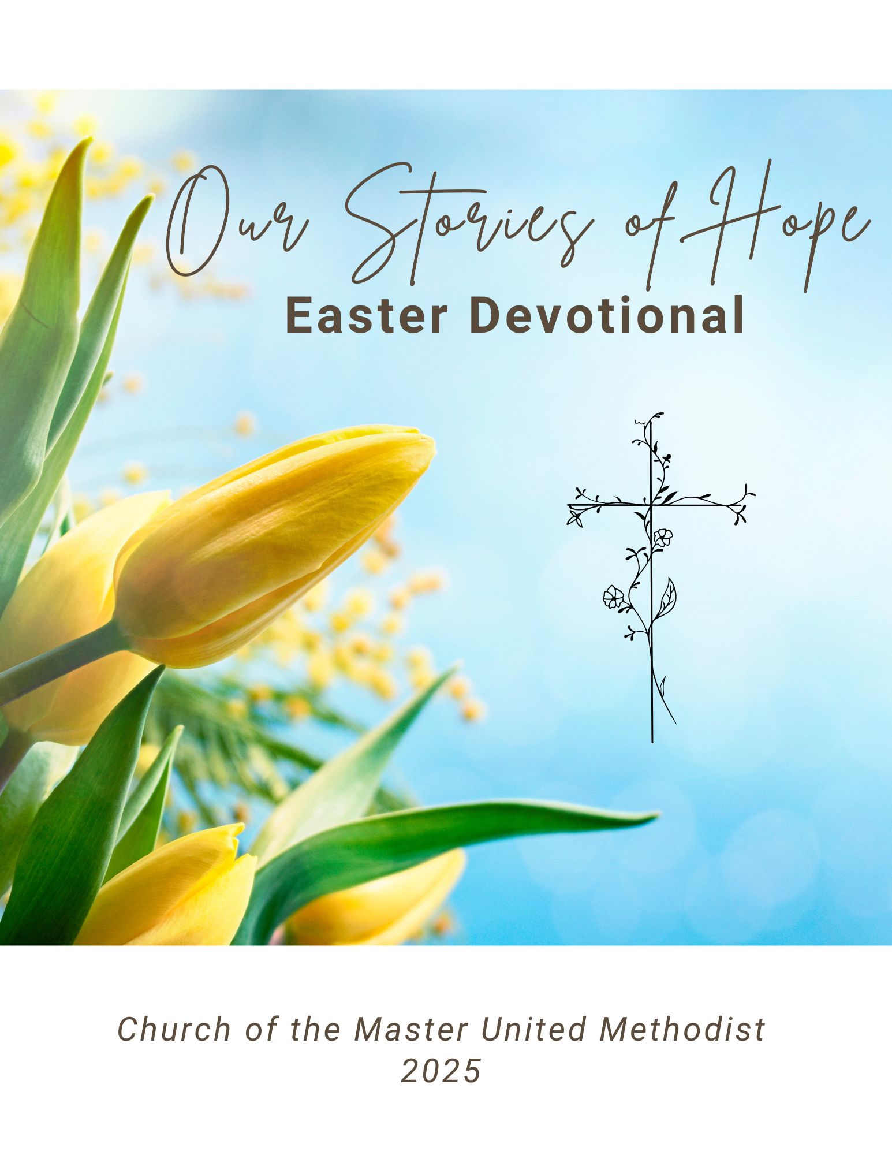

Dear Friends,

Easter is the season of hope—hope that rises from the tomb, breaks through the darkness, and proclaims that life and love have the final word. As we celebrate the Resurrection of Jesus, we also celebrate the ways that hope continues to bloom in our lives today.

This devotional is a collection of personal reflections from members of our church and our community. In these pages, you’ll find stories of faith in the midst of uncertainty, light that emerged from struggle, and the quiet assurance of God’s presence through every season. These are stories of real people, real challenges, and real hope—rooted in the resurrection power of Christ.

The very first devotional in this series holds a special place in our hearts. It is dedicated to Andy Hinton and his loving parents, John and Barb. Andy is a cherished part of our church family. His bright smile and warm greetings on Sunday mornings bring joy to everyone who knows him. Andy lives with cerebral palsy and a seizure disorder, and throughout his life, his parents have been steadfast and devoted caregivers. In Andy’s honor, Linda and Neil Stutz commissioned a hymn that was beautifully performed by the Church’s Chancel Choir a few years ago. As you read this first devotion, may you feel the love, strength, and hope that Andy and his family embody.

Through the stories and words in this devotional, may you be reminded that no matter where you are on your journey, hope is alive. Christ is risen. And because of that, we can face tomorrow with courage, faith, and joy.

Blessed Easter!

Pastor Katya

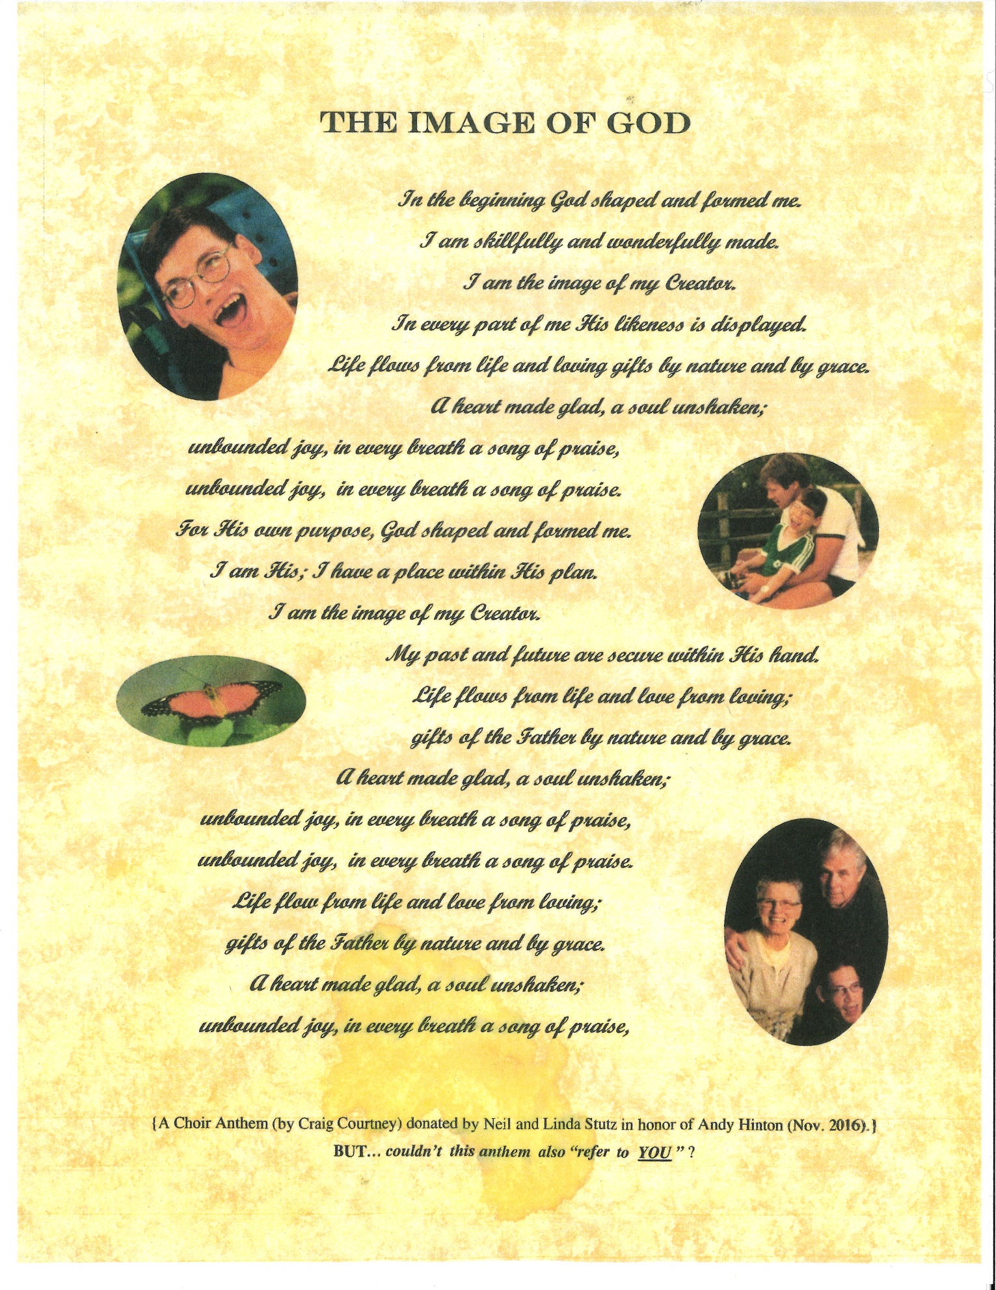

**PSALM 139**

*“You have searched me, Lord, and you know me. You know when I rise; you perceive my thoughts from afar. You discern my going out and my lying down; you are familiar with all my ways.”*

Jr. Choir is a lively group of children. When we sing a song with an exciting beat, they are often on their feet dancing and singing and having a great time, and I kid you not, it sometimes gets out of hand! We often wonder how it is that they actually learn the words and notes, but somehow, they do. This year, in the midst of the upbeat songs, I introduced a prayerful piece called, “He Knows my Name.” We talked about prevenient grace – that before we were born, God knew us and loved us and set a path for us to find Him. The song begins with, “I have a father, He knows my name. Before even time began, my life was in His hands.” It is a simple song and they caught on quickly. They sit quietly in their seats when they sing this one, and many close their eyes. They immediately recognize that the song is a prayer, and they sing with reverence. Friends, it is because of these children that I have hope! God is living and breathing in them and through them, and they are not afraid. God knows their name, He knows my name, and He knows your name. “He knows your name, He knows your every thought, He sees each tear that falls and hears you when you call.”

Lord, thank you for the gift of hope that we have in our children. Thank you for your guiding hand and your ever-present love that leads us to you. Amen

Kitty Laurich

**EVERLASTING HOPE**

*“The people who have walked in darkness have seen a great light. Those who have dwelt in a land of deep darkness, on them has light shone.” Isaiah 9:2*

In the fall of 2021, my grandpa (known as Pippy) got COVID-19. He was in the hospital for a little while before he passed away. While he was sick, we prayed for him to get better. We all had hope that he would get better. Pippy was a faithful man who believed in God. I hoped that because he loved God, that God would help him live. Then one snowy day in November, we realized that we had to say goodbye to him. He was going to heaven. I was shocked, sad, and upset. I thought God would help him, and he didn’t. I was disappointed. But I also felt a sense of comfort and hope that when I go to heaven, I will see him again. Pippy’s passing could have taken us farther from God, but it actually brought us closer. It helped my dad, especially. We wanted to follow in Pippy’s footsteps and love God more.

Dear God, please help the people who are in some of the darkest places of their life. Please pour your light on them. Help them to trust you more with all of their hearts. Amen.

Iris Wells

**PSALM 130:1, 2 and 5, 6**

“*Out of the depths I have cried to Thee, O Lord. Lord, hear my voice!*

*I wait for the Lord, my soul does wait,*

*And in His word do I hope. My soul waits for the Lord more than the watchmen for the morning…”*

My dad’s harsh breathing filled the room at St. Ann’s Hospital in Westerville. My mother sat by his bedside, trying to read a magazine, glancing at his face now and then, hoping he would open his eyes.

My sister and I sat quietly in the only other chairs in the room. We’d run out of hopeful things to say, such as, “he looks a little better today,” or “he has more color in his cheeks,” because my dad’s condition after his stroke had worsened. His face was greyish and for the past two days he’d been unresponsive. His labored breathing continued, hour after hour, but the doctors could offer us no real hope for recovery.

I tried to comfort my mother, but my heart was breaking. My wonderful dad, who had rarely been sick, who spent his days singing as he worked in his garden—old songs like “Don’t sit under the apple tree with anyone else but me,” was dying. I would never hear him call my mom “Honeybunch” again or hear him come into the kitchen with a big smile, greeting my kids with, “Hello, little people!” I had “prayed without ceasing” for days, hoping he would recover, despite what the doctors kept telling us, but now all I could do was pray that he somehow felt how very much we loved him. How much he would be missed and never, ever forgotten.

It was dark outside the hospital window, and my mother’s head was nodding with exhaustion. It was time to take her home.

I went up to the hospital bed, took my dad’s limp hand, leaned in close. “I’ll see you in the morning, Daddy. I love you so much.”

A shock went through me when he feebly squeezed my hand, then one tear, and another, slipped from his closed eyelids. My own eyes brimming, I kissed his cheek and said, “There you are…you heard me. I’ll be back tomorrow, Daddy. Rest well, tonight.”

Despite my tears, my heart filled with so much hope, so much joy as I felt the presence of God in the room. I didn’t know my dad’s breathing would finally stop that night, and that God would gather him in before the morning, but I knew that God was listening to me and had answered my prayers. My dad knew how very, very much he was loved.

Holy God, let us remember that you are with us always, during all of our trials and tribulations, our heartaches and our triumphs, and that you really do hear our prayers and love us more than we could ever know.

Pamela Bennett

**STORY OF HOPE**

In the Spring of 2024, I was feeling quite lost. I had been a member of my church's choir for over 20 years, served as a cantor at mass for over 15 years, and served as the youth choir parent chaperone for 4 years while my (now young adult) child, Harley, had participated. I had committed most of my adult life to the music ministry and we had just been told that our fearless leader, director, and most importantly, friend had decided that it was time to retire from his position as music director.

For years, my husband had done all the Christmas Eve and Easter duties with Harley so that I could be serving in choir or cantering another mass. We had to leave family holidays early every year and I remember driving through inches and inches of snow on Christmas Eve to get to and from church. So you would think that it wouldn't matter who was running the music ministry as much as I loved and had dedicated hours of my life to it. After all, the "show must go on" as they say.

However, over the last 5 or so years of my service to the music ministry, my soul had started to become disconnected. The messages coming from the pulpit each Sunday were not aligning with my heart and certainly were not helping me grow in my relationship with Jesus. I was hearing more and more that I was wrong for offering unwavering love and support for Harley after they came out to us as LGBTQ+, non-binary. The kid that I had raised in that church no longer felt welcome and honestly, I didn't really either, but my years of service and the relationships I had built through serving our Lord in music kept me there, trying to "tune out" the negative week after week.

I've often been the kind of person that God unfortunately has to whack over the head with a metaphorical 2 x 4 before I hear Him. (I have a BAD habit of trying to be too self-sufficient. I'm grateful that He loves me anyway.) So this time that metaphorical 2 x 4 came in the form of a retirement of someone I had respected and served with for all of these years. I guess sometimes God knows when you need a reset. When the choir season ended in late Spring, I was on a search for a new church home. As Harley was now at Otterbein, I had spent a lot of time on campus or "campus adjacent" and the 1st thing that caught my eye was the welcoming sign outside of Church of the Master. "We celebrate you unconditionally as a child of God, made in God's infinite image...". That sign inspired me to walk in for service one Sunday.

Never have I walked into ANY space or place where I had felt more welcomed by the people. So many people knew immediately I was a new face and introduced themselves. So many smiles and "hellos.” While I don't remember the exact sermon from Pastor Katya on my 1st Sunday, I do remember that I lost count of the number of times she had used the word "love.” As the tears filled my eyes and my dear friend Cathy patted my shoulder (she was with me on this journey), I knew God had brought me to this beautiful church filled with His hope.

As Luke 19:10 tells us, "For the Son of Man came to save and to seek what was lost." This time, I was what was lost and you all acted as the hands and feet of Jesus and found me. So I thank you. With immense gratitude and blessings for you all at Church of the Master,

Katy Zappia

**FORGIVENESS...HEALTH....HOPE**

Children are not born with a built-in desire to be forgiving human beings. To illustrate simply observe toddlers at play. If one child takes a toy away from another child, or if one child hits another child, or if one child tries to take over another child’s space, notice the automatic response called ‘revenge’ or ‘get even.’ Forgiveness is a learned response. Parents, other family members, friends, and teachers are the primary instructors in helping children navigate the challenges and the daily obstacles of becoming forgiving persons. Keep in mind that even after learning forgiveness values and benefits, when someone hurts us, the first step is to decide our response. Withholding forgiveness is a decision to not forgive. The highly read author Henri Nouwen reminds us, “Forgiveness is the name of love practiced among people who love poorly.”

Because forgiveness issues confront us every day, note what forgiveness is not:

- covering up the conflict

- making excuses for bad behavior

- condoning unkind and harmful actions

- denying our hurts and feelings

- smiling no matter what happens without addressing the root and cause of the conflict.

So what is forgiveness?  Ponder this dictionary definition: to stop feeling angry or resentful towards someone for an offense, flaw, or mistake. In recent years a notable amount of scientific research has gone into the health benefits of forgiveness. Although the forgiveness process can be complicated, the positive results enhance our health and instill hope in our souls. Because forgiveness is contrary to our basic human nature, forgiveness can best be understood as a gift from God for giving and for receiving. In the Lord’s Prayer, Jesus highlights the necessity of developing forgiveness as a life-style. Note his comment after teaching his prayer: “If you forgive others their sins, your heavenly Father will also forgive you. But, if you don’t forgive others, neither will your Father forgive you your sins.”  Matthew 6:14

In today’s mixed-up, messed-up world, hope is less (a lot less) than abundant. Perhaps we need to start with a review of our personal life and relationships. Keep in mind that forgiveness is a necessary ingredient for health and hope. St. Paul closes his letter to the Church in Rome by emphasizing “hope” as a life-style:

*May the God of hope fill you with all joy and peace in believing so that by the power of the Holy Spirit you may abound in hope.” Romans 15:13*

Prayer: Gracious and Loving God, it’s so easy these days to question humanity’s future on planet earth. The communications media seems too eager to fill our ears and eyes with bad news every day. Remind us, encourage us to turn every day to positive sources such as: regular attendance with other believers at my church, meditating on a verse of Holy Scripture each day, and lifting in prayer the human situations that need the Light and Love of Jesus, God’s gift of hope. Amen!

A verse to ponder: John 14:25-28

Rev. Jim Wagner

*Article by Henri Nouwen in *Weavings* magazine, Upper Room, VII, No.2, 1992, p.15.

**HOPE**

*Hebrews 11:1 “Now faith is the assuranceof things hoped for, the conviction of things not seen.”*

Hope is my favorite word. Hope is the promise of God’s ability to exceed our wildest expectations. When my kids were little, and I was struggling to do and be all the things they needed, God offered me a gift in a new friend. I was dropping my oldest child off at preschool one day, and I received an envelope from the teacher. Inside the envelope was a letter with instructions about a walk-a-thon fundraiser. After reading the letter, I was in tears. We were to raise funds for a little boy who had Cystic Fibrosis. So, I set out to raise as much funds as I could. When the time came for the walk-a-thon, the principal came up to me and told me the mother of the little boy wanted to meet the mom who raised the most funds.

We chatted for a bit before I told her that I shared the same lung disease as her little boy, and that I was beyond touched that a whole preschool would care this much. This was hope. This amazing mom became my best friend. We raised our kids alongside each other. She helped me have a stronger faith in God and faith in myself. She taught me so much about how to advocate for myself and my illness, and I gave her hope that her son could grow up and live a long healthy life (with this disease). I continued to refer to her as my “faith” and she referred to me as her “hope.” God knew I needed this friend, and God poured out abundant blessings through her. Her son and I both still have CF, and we are both thriving!

*God, who offers us hope beyond our imagination, help me to know you are always with me. Help me to see you in the eyes of my friends, in the smile of a stranger, in the laughter of a child. Remind me that with each breath I take, I have hope for wholeness and restoration of your creation. Amen*

Rev. Lucy Kelly, United Methodist Deacon, Assocaite Pastor

**GOD’S GIFT OF BENSON OAKS**

**“***But those who hope in the lord will renew their strength. They will soar on wings like eagles; they will run and not grow weary; they will walk and not be faint.” Isaiah 40:31*

In the spring of last year, I needed a dose of hope. Horseback riding was putting a lot of financial stress on my family. Most would say, and I would agree, that a fun-loving, horse obsessed, 10-year-old, shouldn’t have to worry about money. However, that was not the case. All I thought about was horses. I loved my barn, everybody liked me, and one of the mares had a special bond with me. The only problem with my once-a-week lessons was the cost. In the equine world everything is expensive. We stayed at the barn as long as we could, but soon I had to go. I cried leaving the barn, and intermittently the next two blurry weeks. Miracles are rare and unexpected, but blessed little me got one. We tried or looked at just about every barn in Columbus, when my mom’s friend told us to try the barn her daughter went to. On a Friday, in early May, my family’s red Toyota Sienna minivan pulled into Benson Oaks Barn. When we stepped out, we met with a kind lady named Deanna who gave me a tour and a hope. Two weeks later, and to this day, we have a barn that doesn’t make a now-11-year-old girl worry about money. God never has to answer prayers, and He certainly doesn’t have to give it to you back better than you had it before. I am just grateful that He gave me the opportunity to learn more, grow more, and ultimately share about and encourage others. I will never stop sharing my story of the Benson Blessing.

Dear God, thank you for miracles. Thank you for caring about everybody’s trials and troubles. This Easter season help us all to focus on Your message of hope. Amen

Emilia Wells

**“*May the God of hope fill you with all joy and peace as you trust him, so that you may overflow with hope by the power of the Holy Spirit.” Romans 15:13 NIV***

As I read this scripture, I was reminded of the hope I have in Jesus Christ. I was baptized as an infant, confirmed at age 12 and have gone to church regularly all of my life. At age 18, I attended a New Year’s Eve watch night service at Church of the Master. As I sat in the choir loft with my candle in an otherwise darkened sanctuary in silence, I looked up at the lighted cross and was suddenly overwhelmed by the love of God and knew that Jesus had died for my sin. I continued to grow in my faith in the light of that experience. At age 30, I had a neighbor who told me about the Holy Spirit. That year, I searched for a deeper more personal relationship with God and was once again flooded with the love of God and filled with the Holy Spirit while singing a duet in church, “I waited for the Lord” by Mendelssohn. Suddenly, the God who had seemed distant became real to me and as close as my next breath. The Holy Spirit brought Jesus close, made the scripture come alive, helped me to pray and brought me such joy and peace. I had the assurance and hope of being with Jesus and the Heavenly Father when I died as well as the sense that God would never leave me, no matter what happened in life. I can truly sing, “My hope is built on nothing less than Jesus’ blood and righteousness.

Prayer: Oh, God of hope, fill me with all joy and peace as I trust you more and more. May I overflow with hope by the power of the Holy Spirit.

Ann Peat

**MY GOD IS AN AWESOME GOD**

“*But you, Lord, are a compassionate an*d*gracious God, slow to anger, abounding in love and faithfulness.”* *Psalm 86:15*

I grew up in a very conservative Methodist church.  As a child, I often went to sleep afraid because I had heard something the preacher said that I didn’t understand, but it scared me.  This was the basis for my Christian faith. My husband and I moved to Dallas, Texas, so he could attend Perkins Theological Seminary.  During his first year, he would come home and tell me about the discussions in class.  He didn’t realize it, but he was tearing down the whole foundation for my faith.  He used the next year to help me rebuild a healthier foundation. How grateful I am for a stronger faith that keeps growing. I used to read Jesus’ parables and interpret “pluck out your eye”  or  “cut off your hand”  and think Jesus meant to literally do this.  Now, I interpret it to be a “prophetic hyperbole,” as Adam Hamilton calls it in his Lenten Devotional The Way and explains that this means that Jesus used extreme examples to make a point that His listeners could relate to—not to literally emulate.  Once I was able to grasp this concept, my whole mental perception toward Christianity changed.  It made more sense … was more productive … and more enjoyable.  We have a loving God who will, if we let Him, help us to move forward as we mature in our faith, guiding us every step of the way.  What a wonderful source of hope as we grow in our faith.

Thank you, God, for being an awesome God and for always being available in our times of trouble and joy.  Amen.

Remona Carter

**HOPE OF HEAVEN**

“*And God will wipe away every tear from their eyes. There will be no more death, nor sorrow, nor crying, nor pain. For the former things have passed away.”  Revelation 21:4*

Somedays it is easier to praise God than others. Somedays it takes everything we have to get through the day; we crash into bed at night with tired minds, bodies, or spirits (and sometimes all three). Sometimes it feels like our worries and hardships are never-ending. On these days, I work hard to remind myself of just one thing: there will be a day when those things will be end. Through our faith in Jesus, every tear will be wiped away; there will be no suffering, injustice, agony, fear, or pain. It sounds impossible, and yet it is so. That is God’s promise to us, and that is where I find the greatest hope of all, the hope of heaven.

Dear Lord Jesus, please be with me through each day. Help me to remember that when times are trying and tough, you have made a way for your children to find their way back to you. You have given us a home and hope in heaven. Amen

Stephanie Proctor-Wells

**HOPE IN GOD**

#### I once found an excellent description of depression. "[Depression is] like your brain is wearing a full-body armor designed to keep only the good things out. Bad things -- negative comments from your boss … petty complaints from your mother -- get ushered in instantly, like VIPs."

#### Lent and Easter provide an excellent time in which to renew one’s relationship with God...but if you're prone to depression (as I've been all my life) the penitential aspects of the season could possibly make a person sadder than before.

#### During any time of the year, a depressed person might include psalms among devotional reading. The psalms are wonderful prayers because many of them are quite forthright about the psalmists' distress! Psalms 42 and its companion 43 are examples. "For you are the God in whom I take refuge; why have you cast me off?" (Ps. 42:2). What a terrible concern, that God is not only silent but has rejected the psalmist! Fortunately, that isn't the last word, for the psalmist knows to "hang on": "Hope in God; for I shall again praise him, my help and my God" (vs. 5). The psalmist isn't feeling praiseful now but will eventually.

#### When you’re downhearted, you can prayerfully focus upon scriptures that depict God as a "place" of help. God is our machseh, which means "refuge" (Deut. 33:27, KJV and NIV) or “dwelling place” (RSV). Psalm 46:1 affirms that “God is our refuge and strength, a very present help in trouble.” Imagine God as a welcoming "place" to go when you're downhearted.

#### Sometimes the funk is difficult to shake, but God hears us where we are now (Gen. 21:17), and God is greater than our hearts (1 John 3:19-20). Banish all thoughts of divine disapproval and think of God as being grateful to help you through rough times.

#### Dear Lord: If we’re not feeling hopeful, you hang in with us! We offer you the struggles of our hearts and lives and look to you as our safe place. Amen.

#### Paul Stroble

*“****Now faith is the assurance of things hoped for, the conviction of things not seen.” Hebrew 11:1***

There are many seasons in our lives when it’s easy to forget God’s promises: God’s promise that God will always be with us and God’s promise of unconditional love. One of those seasons was shortly after I was married, and my husband and I were trying to start our family.

We had been married for a little over a year and were excited to be starting our family, however I sensed something was wrong after a few months of unsuccessfully trying to get pregnant. After several more months, I went to my doctor to start exploring why I hadn’t gotten pregnant yet. One test led to another test, which ultimately led to various procedures to assist in the process of trying to become pregnant. Then one year turned into two years, which turned into three years, and so on.

There were days it was impossible to have hope that we’d have a child. I tried to put my hope in God and His promises, but truthfully that didn’t always provide the comfort I was seeking and desperately needed. Month after month, my heart was crushed, and I began to question God, and why He would give me such a strong desire to become a mother then not allow it to happen.

What I remember most about that season of life was that when I lost my hope of being a mom, there were others around me who would *hope* for me. I had family and friends who never lost hope and helped carry and support me when I felt hopeless. Eventually, after over 5 years of trying, we became pregnant with our daughter. Having her (and her brother a couple of years later) have been the two best gifts God has given me!

I know our seasons of hope don’t always turn out as we had planned, I have many examples from my life of that as well. However, regardless of what we are hoping for, we can always have faith in the assurance that God will always love us, and that God never leaves us. We never have to hope for God’s love, it’s a gift that is always there for us!

Kris Frantz-Shoaf

**LAMENTATIONS 3:22-23**

Have you ever been unable to enjoy what should be a period of joy in your life because you can’t stop dreading the inevitable end? My last years of high school went well. Suspiciously so. I’d gotten a full ride scholarship to Otterbein, and everyone around me showed such love and support towards the start of my college journey. My family was healthy, I had plenty of free time, and my high school career was all downhill from there. Yet I couldn’t help but feel like I’d used up all my blessings in childhood and that the pendulum would have to swing back at some point. I got to college, and while the first week was hard, I met up with a fellow student I’d been emailing over the summer and a close knit friend group started to build around us. When classes started, I settled into a schedule that reflected my interests and passions.

While I’d hoped my life wouldn’t get worse, I had never thought to hope it might get better. Jesus had been there all along, trying to tell me that joy doesn’t come from freezing perfect moments, but from trusting that there will be more of those good things in the future. Hope isn’t only for hard times; hope is for the everyday because there’s no divine accountant rationing out blessings. There’s only God’s unending mercy and relentless love.

Merciful God, you owe us nothing but give us everything through Jesus. Forgive us when we fall back on the assumption that what is good cannot last, because You are good and Your hope can be a part of our lives in great times and terrible ones. May we remember to cherish each moment as a gift from You and trust that there is always more where they came from. Amen.

Alea Simbro

**ECCLESIASTES 3:11  *God has made everything beautiful in its time.***

When I was growing up in the valley surrounding the San De Cristo Mountains in Southern Colorado, each Easter morning the youth groups of the Methodist Churches in the valley and sponsors would travel to the southern edge of the mountains and watch the Sunrise appear over the mountain top. It was so beautiful and meaningful each Easter morning.  We had a devotional there as it was rising.

Each Easter I relive the sunrise experience and often watch the sunrise wherever I have lived on Easter Sunday.

Each day I enjoy the beauty of nature as I walk around Westerville, the birds, the flowers blooming and of course the rising and setting of the sun.

Prayer: Dear God, we thank you for the beauty of nature and for Jesus Christ our Savior and his teachings to guide our lives.

Janice Eddy

**BEHOLD, I WILL MAKE ALL THINGS NEW**

***(****1) “Then I saw a new heaven and a new earth: for the first earth and the first heaven had passed away…. (5) And he that sat upon the throne said, “Behold I make all things new” … Revelation 21, 1,5*

My Mother loved the United Methodist Church and the United Methodist Women. Liberal in her thoughts, she stood alone in our front yard, beneath the flag that always flew there, during a national protest of the Vietnam War. As a young WWII bride-to-be, she clipped a button off of my Dad’s uniform and said: “I’ll wait for you.” He returned late, having been a POW in Romania. They were married 60 years and raised my sister, myself, and two brothers with faith and with fervor: ever grateful for the peace and freedom that had so hung in the balance, during their young adult lives.

As a 90-year-old, mother had returned from the hospital after a brief stay for GI distress. We were hopeful that she was on her way to a period of well-being. During the evening, she became distressed, restless and stood up raising her arms toward the window with her hands on the wall, pushing upward and told us she was, “going to the new Church.” We reminded her of her Church, less than a mile away in our small town, and that we would take her there the next morning. Never a person to be dissuaded, she continued to insist that she was, “going to the new Church.” Mom passed away in the hospital later that evening, stating with continual insistence that she had to go, as she was, “going to the new Church.”

In closing her funeral service, our pastor recited the passage from Revelations that proclaimed the creation of a new heaven and a new earth, which we pray, would include Mom’s, new Church. My faith is renewed and affirmed when I read, hear and recall these words. I feel blessed by my mother’s faithful and confident assertion; that was, and always had been: on our behalf.

Dear God, As spring arrives, renew us like the buds that emerge from their pods, seeded with fragile faith that seeks the sun. Allow us, dear Lord, to peak across the furrows of our own lives, to send shoots and roots of love that nourish the soil of our neighbors. In so doing, may we be blessed to discover the rare earth of your infinite love. Amen

Katie Conklin

**A SEASON FOR HOPE**

“*May the God of hope fill you with all joy and peace in faith so that you may overflow with hope by the power of the Holy Spirit.” Romans 15:13*

In Eastertide, we welcome a season of hope. We celebrate the Risen Christ and embrace with praise and thanksgiving the gift and promise of Resurrection. Hallelujah and Amen!

For many, this joyful season also marks a time of academic celebrations. Throughout my life and career as an educator, spring has been a time to celebrate commencements. While some people love weddings, I love commencement ceremonies. I love the pageantry and processionals. I love sharing joy and gratitude with students and families. They have sacrificed so much and aspire to so much more. To be part of that is a blessing, and I always enjoyed preparing my remarks of encouragement and congratulations for them.

Now that I have retired, this is the first spring in 50 years that I am not participating in or leading a commencement ceremony. Until I read this week’s column by Frank Bruni, I had not thought about how challenging it is for this season’s speakers to strike the right tone and provide meaningful messages amid the disruptive conditions new graduates will face. In his April 10, 2025 *New York Times* column, “What do you tell a college student graduating into this America?” Bruni ponders his response when a graduating student asked him where he finds hope. He admits that he has felt such anger and sorrow at life’s events that he was ill-prepared to provide needed encouragement for one soon to face new challenges of life and work. He understood her fears for an uncertain future.

I paused to think about how I would respond. How can students’ fears be allayed and their hope affirmed? I believe hope is at the heart of facing fear, but it is a matter of where hope resides. If we approach hope as a strategy, then we may be placing hope primarily in our own power or abilities. If instead we have hope because of our joy and peace in the faith of already being redeemed by God, then our hope resides in a power greater than our own. Thanks be to the power of the Holy Spirit for an overflowing hope.

How did Bruni respond? In his words, “I said that her shock at the current turn of events is a reminder that we never know what’s coming next, and while that question mark can be terrifying, it can also be a solace. I said that the unpredictability of the story reflected its many authors, she and I among them. We have by no means reached a point of helplessness, but we will most certainly get there if we declare defeat too soon. Hope isn’t an option. It’s an obligation.”

Lord God, creator, redeemer, holy comforter, when the times rock our confidence and inner peace, help us hold to our hope in you. Give us the courage and confidence to overflow with hope, to be givers of hope to others, messengers of the eternal hope found only in you. Amen.

Beth Stroble

**AN UNFORGETTABLE EASTER MORNING**

“*On the first day of the week, early in the morning the women took the spices they had prepared and went to the tomb.” (Luke 24:1)*

It was a perfect Easter morning as we headed for church, The sky was blue; the sun

shone brightly; daffodils and tulips popped up everywhere; the birds were singing, Our spirits

were lifted as we entered the building. The hope of the resurrection was in our hearts.

But once inside, we noticed the sanctuary lights were dimmed very low. We heard no

music. There was no lily cross, nor daffodils, nor tulips. Everything was quiet. Not what we

expected at all! The choir formed in the gathering space, looking anxiously around, trying to

figure out what was going on.

Shortly before the service was to begin, three women dressed in clothing from Jesus’ time,

came across the gathering space and headed down to the chancel area talking among themselves

quietly as they walked. A big black curtain was covering the entire chancel area. *Where was the hope of the empty tomb and the resurrection?*

After they looked around, one of the women made a motion and the giant black curtain

came down. At that moment the lights went up, the organist fired up the organ to the strains of

the Easter hymn *"Welcome happy morning, age to age shall say..."* and there was the lily Cross

in all its splendor, surrounded by a beautiful array of Easter flowers,

The stone was rolled away. He is risen. The choir processed and the celebration of the

risen Lord began. As I sat there awed by everything around me, I thought how much the first

Easter morning, and this Easter morning were the same- -both filled with hope at the sight of the

empty tomb and the risen Christ. I knew then that this would be an Easter morning that I would

never forget!

Prayer: "God sent His son, They called him Jesus. He came to love, heal, and forgive

He bled and died to buy my pardon. An empty grave is there to prove my Savior lives." (Bill and Gloria Gaither)

Barb Hinton